Sunday Jazz In the Park
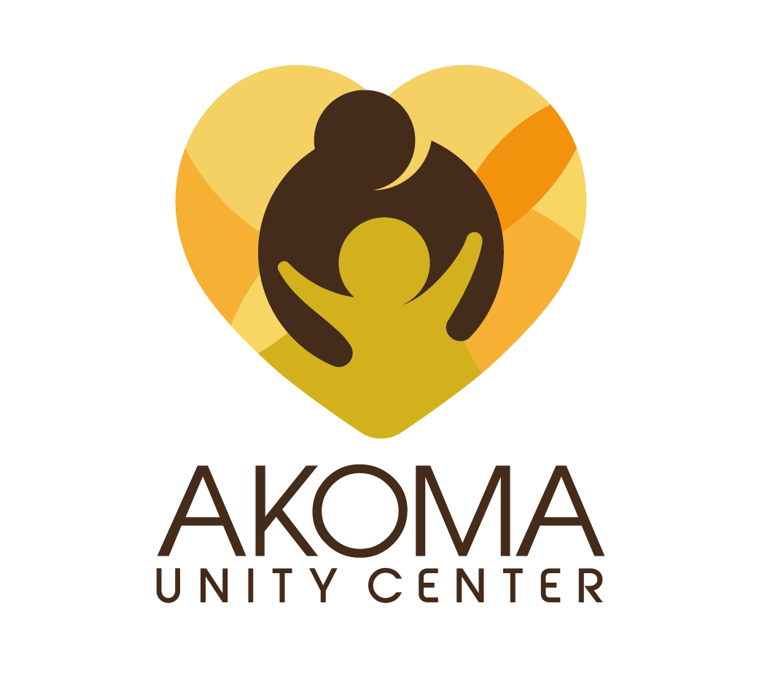
Hosted by Akoma Unity Center
Vendor Registration Form
Sunday, September 30, 2018
4:00pm-9pm
Anne Shirrells Park 1367 N. California St. San Bernardino, CA 92411

Exhibitor space is limited and will be available on a first come first serve basis as we receive your Donation of:
Merchandise Vendor ($75) - Arts & Crafts, Unique Items, Clothing, Pictures
BYO tables/chairs. Otherwise, rent them from Akoma for $25 per table/$10 per chair
Food Truck ($150.00) food vendors are responsible for their own county fees
No Refunds
Set up: 12pm – 3pm.
Exhibitors must prepare their tables no later than 3:00 p.m.
Please submit this form no later than Thursday, September 20, 2018
Questions about Registration? Email erika@akomaunitycenter.org.

Organization: __________________________________________________________
Contact Person: ______________________________________Title:____________________________________
Address: ____________________________________ City: ________________________ Zip: ________________
Phone Number: _____________________________ Email: _____________________________________
Type of Booth: ______________________________ Items Being Sold: ________________________________
Names of those who will be attending:
Representative 1___________________________Representative 2___________________________

Credit Card payment information:
Number ______________________Expr Date____/_____/ CVS code_________ Zip Code__________
Mail check or money order to: Akoma Unity Center Mail to: 985 Kendall Dr. Suite A-319 San Bernardino, CA 92407
Make payments online at: akomaunitycenter.org

Waiver and Release Agreement
It is understood that I, the above signed participant, cannot participate in Akoma Unity Center’s Sunday Jazz In The Park until this WAIVER form has been completed. Akoma Unity Center, Inc. is not responsible for your equipment, materials, display, your loss of income, bodily injury or loss of life caused by fire, rain, windstorms, earthquakes or other natural disasters. I hereby give free use of my name and picture in any broadcast, social media, telecast or print media of this event.
I acknowledge that I have read the above and do fully understand Akoma Unity Center is not responsible if something were to happen to me. For more information, please call, (909) 217-7956.
_________________________________________________ _______________
Vendor Signature Date

